Riga Technical University

FACULTY OF COMPUTER SCIENCE AND INFORMATION TECHNOLOGY

Fundamentals of Computer Graphics and Image Processing

Practical Work 4

TASK 4. 2D TRANSFORMATIONS

+ ADDITIONAL TASK

FCSIT
International Student
ZAID AHMAD SIDDIQUI
Stud. ID Nr.191ADB044

1.Task of Work
- During class you will be given the transformation algorithm that can rotate an object that is made from four vertices. Change this program so that you could rotate the object around any selected vertex. The amount of vertices of the object should be taken from the table below.
- The protocol should contain at least 2 screenshots that show the results of rotation (before and after rotation)
- Upload the protocol of the task to Ortus (in *.pdf, *.doc or *.docx formats)
Variant  (the last digit of your student ID) | Amount of control points
0 | 6
1 | 7
2 | 8
3 | 9
4 | 6
5 | 7
6 | 8
7 | 9
8 | 8
9 | 7

Programming Code
public static int [] [] Vertices =new int [6] [2];
public static int cX,cY;
private void jButton1ActionPerformed(java.awt.event.ActionEvent evt) { Random val = new Random();
cX = jPanel1.getWidth() / 2;
cY = jPanel1.getHeight() / 2;
for(int i = 0 ; i<6 ; i++){
Vertices[i][0] = cX - val.nextInt(jPanel1.getWidth()); //object cant be bigger than panel

Vertices[i][1] = cY - val.nextInt(jPanel1.getHeight());

}

DrawObject();

}

private void jPanel1MousePressed(java.awt.event.MouseEvent evt) {

int i=0;

if(jRadioButton1.isSelected()) i=0;

if(jRadioButton2.isSelected()) i=1;

if(jRadioButton3.isSelected()) i=2;

if(jRadioButton4.isSelected()) i=3;

if(jRadioButton5.isSelected()) i=4;

if(jRadioButton6.isSelected()) i=5;

Vertices[i][0]=evt.getX()-cX;

Vertices[i][1]=cY-evt.getY();

DrawObject();

}

private void jButton2ActionPerformed(java.awt.event.ActionEvent evt) {

double alfa = Math.toRadians(Double.parseDouble(jTextField2.getText()));

int n=6;

if(jRadioButton1.isSelected()) n=0;

if(jRadioButton2.isSelected()) n=1;

if(jRadioButton3.isSelected()) n=2;

if(jRadioButton4.isSelected()) n=3;

if(jRadioButton5.isSelected()) n=4;

if(jRadioButton6.isSelected()) n=5;

for (int i=0;i<6;i++){

double xn = Math.cos(alfa)*(Vertices[i][0]-Vertices[n][0]) - Math.sin(alfa)*(Vertices[i][1]-Vertices[n][1]);

double yn = Math.sin(alfa)*(Vertices[i][0]-Vertices[n][0]) + Math.cos(alfa)*(Vertices[i][1]-Vertices[n][1]);

Vertices[i][0] = (int)Math.round(xn) + Vertices[n][0];

Vertices[i][1] = (int)Math.round(yn) + Vertices[n][1];

}

DrawObject();

}

public void DrawObject(){

Graphics g = jPanel1.getGraphics();

g.setColor(Color.WHITE);

g.fillRect(0, 0, jPanel1.getWidth(),jPanel1.getHeight());

for (int i=0;i<6;i++){

int x1 = Vertices[i][0]+cX;

int y1 = cY-Vertices[i][1];

g.setColor(Color.red);

g.fillOval(x1-4, y1-4, 8, 8);

g.setColor(Color.black);

g.drawString(String.valueOf(i+1), x1-3, y1-6);

int x2,y2;

if(i<5){

x2 =Vertices[i+1][0]+cX;

y2 =cY-Vertices[i+1][1];

}else{

x2 = Vertices[0][0]+cX;

y2 = cY-Vertices[0][1];

}

g.drawLine(x1, y1, x2, y2);

}

}

ScreenShots

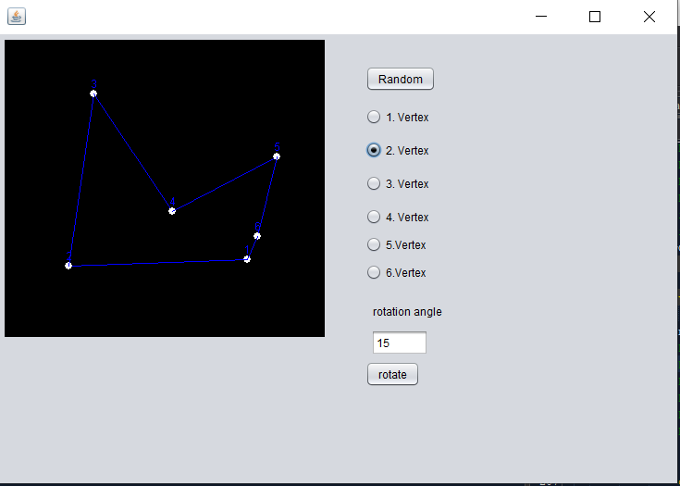
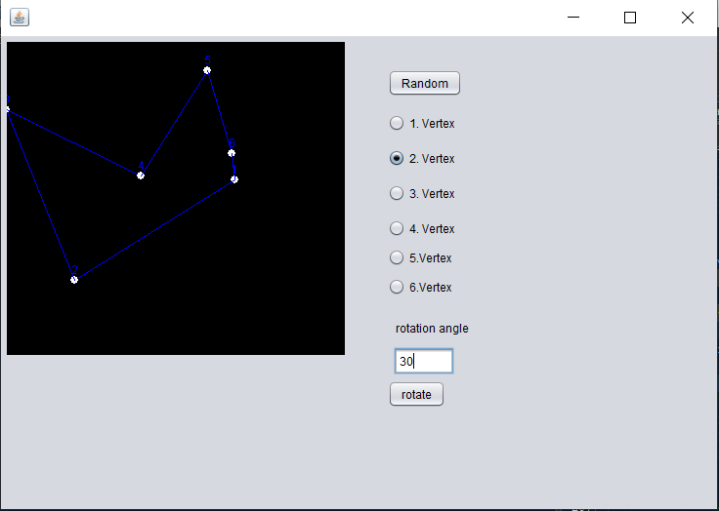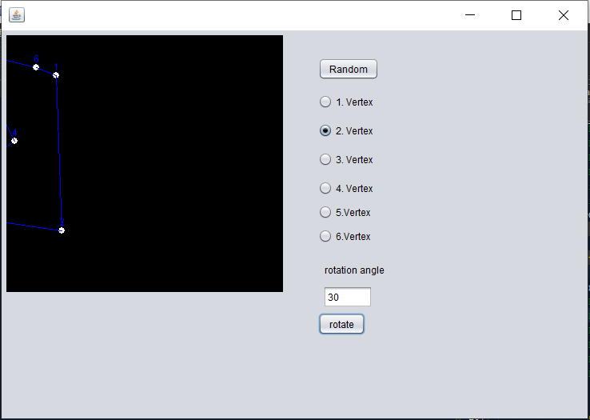

ADDITIONAL TASK

Task of Work
- Make it possible to change the amount of vertices (up to 11).
- Implement all 2D transformations (Rotate, Scale, Move), using the transformation matrix.
- Upload all program files to Ortus in an archive (in *.arj, *.zip or *.7z formats)

Programming Code

public static int [] [] Vertices =new int [11] [2];
public static int cX,cY;

private void jButton1ActionPerformed(java.awt.event.ActionEvent evt) {
Random val = new Random();
cX = jPanel1.getWidth() / 2;
cY = jPanel1.getHeight() / 2;
for(int i = 0 ; i<num ; i++){
Vertices[i][0] = cX - val.nextInt(jPanel1.getWidth());
Vertices[i][1] = cY - val.nextInt(jPanel1.getHeight());

}
DrawObject();

}

private void jPanel1MousePressed(java.awt.event.MouseEvent evt) {
int i=0;
if(jRadioButton1.isSelected()) i=0;
if(jRadioButton2.isSelected()) i=1;
if(jRadioButton3.isSelected()) i=2;
if(jRadioButton4.isSelected()) i=3;
if(jRadioButton5.isSelected()) i=4;
if(jRadioButton6.isSelected()) i=5;
if(jRadioButton12.isSelected()) i=6;
if(jRadioButton13.isSelected()) i=7;
if(jRadioButton14.isSelected()) i=8;
if(jRadioButton15.isSelected()) i=9;
if(jRadioButton16.isSelected()) i=10;
Vertices[i][0] = evt.getX() - cX;
Vertices[i][1] = cY - evt.getY();

DrawObject();

// TODO add your handling code here:
}

private void jButton2ActionPerformed(java.awt.event.ActionEvent evt) {

double a = Math.toRadians(Double.parseDouble(jTextField1.getText()));
double b = Math.toRadians(Double.parseDouble(jTextField3.getText()));
double c = Math.toRadians(Double.parseDouble(jTextField5.getText()));
double d = Math.toRadians(Double.parseDouble(jTextField6.getText()));
int n=11;
if(jRadioButton1.isSelected()) n=0;
if(jRadioButton2.isSelected()) n=1;
if(jRadioButton3.isSelected()) n=2;
if(jRadioButton4.isSelected()) n=3;
if(jRadioButton5.isSelected()) n=4;
if(jRadioButton6.isSelected()) n=5;
if(jRadioButton12.isSelected()) n=6;
if(jRadioButton13.isSelected()) n=7;
if(jRadioButton14.isSelected()) n=8;
if(jRadioButton15.isSelected()) n=9;
if(jRadioButton16.isSelected()) n=10;

for (int i=0;i<num;i++){
// double xn = Math.cos(alfa)*(Vertices[i][0]-Vertices[n][0]) - Math.sin(alfa)*(Vertices[i][1]Vertices[n][1]);
//double yn = Math.sin(alfa)*(Vertices[i][0]-Vertices[n][0]) + Math.cos(alfa)*(Vertices[i][1]Vertices[n][1]);
double xn = Math.cos(a)*(Vertices[i][0]-Vertices[n][0]) - Math.sin(b)*(Vertices[i][1]-Vertices[n][1]);
double yn = Math.sin(c)*(Vertices[i][0]-Vertices[n][0]) + Math.cos(d)*(Vertices[i][1]-Vertices[n][1]);
Vertices[i][0] = (int)Math.round(xn) + Vertices[n][0];
Vertices[i][1] = (int)Math.round(yn) + Vertices[n][1];

}
DrawObject();
}

private void jButton3ActionPerformed(java.awt.event.ActionEvent evt) {
double a = Math.toRadians(Double.parseDouble(jTextField1.getText()));
double b = Math.toRadians(Double.parseDouble(jTextField3.getText()));
double c = Math.toRadians(Double.parseDouble(jTextField5.getText()));
double d = Math.toRadians(Double.parseDouble(jTextField6.getText()));

for (int i=0;i<num;i++){
double xn = a*(Vertices[i][0]) + b*(Vertices[i][1]);
double yn = c*(Vertices[i][0]) + d*(Vertices[i][1]);
Vertices[i][0] = (int)Math.round(xn) + Vertices[i][0];
Vertices[i][1] = (int)Math.round(yn) + Vertices[i][1];

}
DrawObject();
}

private void jButton4ActionPerformed(java.awt.event.ActionEvent evt) {

double e=Integer.parseInt(jTextField4.getText());
double f=Integer.parseInt(jTextField7.getText());

for (int i=0;i<num;i++){
double xn = 0;
double yn = 0;
Vertices[i][0] = (int)Math.round(xn) + Vertices[i][0]+(int)f;
Vertices[i][1] = (int)Math.round(yn) + Vertices[i][1]+(int)e;

}
DrawObject();
// TODO add your handling code here:
}

private void jComboBox1ActionPerformed(java.awt.event.ActionEvent evt) {
String VN = String.valueOf(jComboBox1.getSelectedItem());
num = Integer.parseInt(VN);
switch(num){
case 3:
jRadioButton3.setEnabled(true);
jRadioButton4.setEnabled(false);
jRadioButton5.setEnabled(false);
jRadioButton6.setEnabled(false);
jRadioButton12.setEnabled(false);
jRadioButton13.setEnabled(false);
jRadioButton14.setEnabled(false);
jRadioButton15.setEnabled(false);
jRadioButton16.setEnabled(false);
break;

case 4:
jRadioButton4.setEnabled(true);
jRadioButton5.setEnabled(false);
jRadioButton6.setEnabled(false);
jRadioButton12.setEnabled(false);
jRadioButton13.setEnabled(false);
jRadioButton14.setEnabled(false);
jRadioButton15.setEnabled(false);
jRadioButton16.setEnabled(false);
break;

case 5:
jRadioButton4.setEnabled(true);
jRadioButton5.setEnabled(true);
jRadioButton6.setEnabled(false);
jRadioButton12.setEnabled(false);
jRadioButton13.setEnabled(false);
jRadioButton14.setEnabled(false);
jRadioButton15.setEnabled(false);
jRadioButton16.setEnabled(false);
break;

case 6:
jRadioButton4.setEnabled(true);
jRadioButton5.setEnabled(true);
jRadioButton6.setEnabled(true);
jRadioButton12.setEnabled(false);
jRadioButton13.setEnabled(false);
jRadioButton14.setEnabled(false);
jRadioButton15.setEnabled(false);
jRadioButton16.setEnabled(false);
break;

case 7:
jRadioButton4.setEnabled(true);
jRadioButton5.setEnabled(true);
jRadioButton6.setEnabled(true);
jRadioButton12.setEnabled(true);
jRadioButton13.setEnabled(false);
jRadioButton14.setEnabled(false);
jRadioButton15.setEnabled(false);
jRadioButton16.setEnabled(false);
break;

case 8:
jRadioButton4.setEnabled(true);
jRadioButton5.setEnabled(true);
jRadioButton6.setEnabled(true);
jRadioButton12.setEnabled(true);
jRadioButton13.setEnabled(true);
jRadioButton14.setEnabled(false);
jRadioButton15.setEnabled(false);
jRadioButton16.setEnabled(false);
break;

case 9:
jRadioButton4.setEnabled(true);
jRadioButton5.setEnabled(true);
jRadioButton6.setEnabled(true);
jRadioButton12.setEnabled(true);
jRadioButton13.setEnabled(true);
jRadioButton14.setEnabled(true);
jRadioButton15.setEnabled(false);
jRadioButton16.setEnabled(false);
break;

case 10:
jRadioButton4.setEnabled(true);
jRadioButton5.setEnabled(true);
jRadioButton6.setEnabled(true);
jRadioButton12.setEnabled(true);
jRadioButton13.setEnabled(true);
jRadioButton14.setEnabled(true);
jRadioButton15.setEnabled(true);
jRadioButton16.setEnabled(false);
break;

case 11:
jRadioButton4.setEnabled(true);
jRadioButton5.setEnabled(true);
jRadioButton6.setEnabled(true);
jRadioButton12.setEnabled(true);
jRadioButton13.setEnabled(true);
jRadioButton14.setEnabled(true);
jRadioButton15.setEnabled(true);
jRadioButton16.setEnabled(true);
break;
}
}

private void jButton5ActionPerformed(java.awt.event.ActionEvent evt) {

for (int i=0;i<num;i++){

double e=(Vertices[i][0])*Math.toRadians(Double.parseDouble(jTextField8.getText()));
double f=(Vertices[i][1])*Math.toRadians(Double.parseDouble(jTextField9.getText()));
double xn = 0;
double yn = 0;
Vertices[i][0] = (int)Math.round(xn) + Vertices[i][0]+(int)f;
Vertices[i][1] = (int)Math.round(yn) + Vertices[i][1]+(int)e;

}
DrawObject();

}

private void jButton6ActionPerformed(java.awt.event.ActionEvent evt) {
double a = Math.toRadians(Double.parseDouble(jTextField1.getText()));
double b = Math.toRadians(Double.parseDouble(jTextField3.getText()));
double c = Math.toRadians(Double.parseDouble(jTextField5.getText()));
double d = Math.toRadians(Double.parseDouble(jTextField6.getText()));

double j=Integer.parseInt(jTextField10.getText());

for (int i=0;i<num;i++){

double xn = a*(Vertices[i][0]) + b*(Vertices[i][1])+(int)j;
double yn = c*(Vertices[i][0]) + d*(Vertices[i][1])+(int)j;
Vertices[i][0] = (int)Math.round(xn) + Vertices[i][0];
Vertices[i][1] = (int)Math.round(yn) + Vertices[i][1];

}
DrawObject();
}

public void DrawObject(){
Graphics g = jPanel1.getGraphics();
g.setColor(Color.WHITE);
g.fillRect(0, 0, jPanel1.getWidth(),jPanel1.getHeight());
for (int i=0;i<num;i++){
int x1 = Vertices[i][0]+cX;
int y1 = cY-Vertices[i][1];
g.setColor(Color.red);
g.fillOval(x1-4, y1-4, 8, 8);
g.setColor(Color.black);
g.drawString(String.valueOf(i+1), x1-3, y1-6);
int x2,y2;
if(i<num-1){
x2 =Vertices[i+1][0]+cX;
y2 =cY-Vertices[i+1][1];
}else{
x2 = Vertices[0][0]+cX;
y2 = cY-Vertices[0][1];

}
g.drawLine(x1, y1, x2, y2);
}

}

ScreenShots
